Kurkure Rolls Out its Mega Consumer Connect Program for Rural India with ‘Caravan Talkies’
by EVENTFAQS Bureau Marketing | March 18, 2019 | Press Release
As part of rural expansion plans, brand Kurkure announced the roll-out of ‘Caravan Talkies’ a mega consumer connect program in Uttar Pradesh. ‘Caravan Talkies’ will travel across 1000+ towns and villages, reaching out to the rural population of Uttar Pradesh.
As part of this initiative, Caravan Talkies will conduct street plays (Nukkad Natak) in these 1000+ towns and villages followed by movie screenings for the consumers. The Nukkad Natak, written exclusively for ‘Caravan Talkies’ will be performed by a team of professional artists, highlighting Kurkure’s new positioning “Khayaal toh chatpata hai” that focuses on progressive ideologies that the homemaker holds today. The Nukkad Natak will be delivering ‘thought-provoking’ stories in a fun and interactive way across various cities and districts in UP namely Lucknow, Kanpur, Meerut, Moradabad, Bariley, Gorakhpur, Ghaziabad, Kheri, Bahraich, Balrampur, Kannoj, Unnao, Rampur and Baghpat among others, starting this March till May 2019.
In addition, the Kurkure team will travel in a branded caravan to designated villages meeting with retailers and educating them about the brand and helping them in setting up with displays and branding.
Speaking about Kurkure’s rural expansion, Dilen Gandhi, Director Marketing, Foods Category, PepsiCo India shared “Rural market, today, represents the next phase of growth in India. As Kurkure accelerates its rural expansion, our initiative is designed to connect and engage with consumers and retailers through relevant brand experiences. This expansion is timed perfectly, as we embark on a new journey with our brand mantra, ‘Khayaal Toh Chatpata Hai’. The new positioning underlines brand’s continued efforts to recognize the Indian homemaker, who has been the center force in bringing families together. We are confident that Caravan Talkies will help us in taking this thought forward amongst our consumers”

Dabur Red Paste Partners Impact Communication to Engage Devotees at Magh Mela 2018
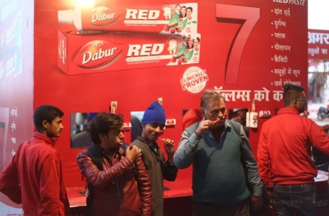
| February 23, 2018 | News Dabur Impact Communications
Sangam Snan is a holy dip is taken by millions of pilgrims visiting the Mela from across the country. It is believed that through this ritual a devotee can wash away their sins and attain ‘Moksha’. No pilgrimage is complete without holy chant playing to ignite the real spiritual fever.
Hinging on this insight and taking forward the tradition, Dabur Red Paste partnered with Impact Communications to service the pilgrims in Magh Mela 2018 by deploying an Oral Hygiene Zone at a prominent location to cater to the captive audience.
“Dabur Red Paste Dant Snan” as a platform was built on the insight that the pilgrims desire to be cleaned at every level at the Sangam. For the same, an innovative unit was created and placed at the ghats wherein visitors are invited to Brush with Dabur Red Paste in the spiritual environment supported by Om Chants interweaved with the message of 7 key benefits.
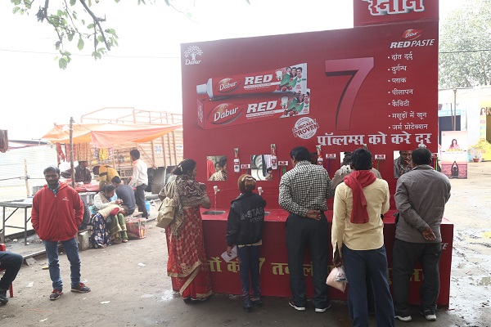
Dabur had placed multiple such units at various locations to cater to the large influx of pilgrims visiting the ghat. It gave the pilgrims a unique & divine experience to the pilgrims while brushing in such positive environment. Massive visibility was created around Dabur Red Paste Dant Snan through posters and banners at key touchpoints.
Harkawal Singh, Marketing Head – Oral Health Care Division, Dabur said, “Dabur India Ltd. is spreading message of Oral Hygiene amongst Lakhs of devotees at the ongoing Magh Mela using a unique toothpaste dispenser at an exclusive Dabur Red Paste – Dant Snan Zone inside the fair premises in service of pilgrims”.
Sunil Sharma – Head, Marketing Activations, Dabur said, “This is a unique property created for the brand that has not only helped to build affinity towards Dabur Red Paste & its Ayurveda based products amongst the masses but also helped to enhance brand strength”.
"Appetite of the rural consumer for more enticing activations has increased with the changing times. The technological intervention of musical Om Chants aided the campaign reach and was the high point of our concept"- said Nidhi Singh, COO Impact Communication.
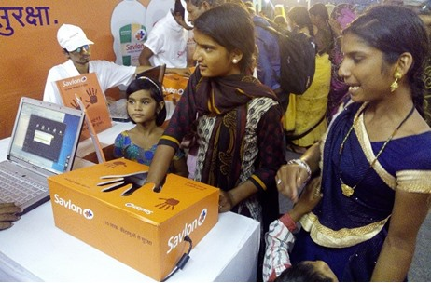
How Savlon Propagated Its Hand Hygiene Programme to Masses at Simhasth Kumbh
by Shantanu Jain Marketing | June 8, 2016 | Feature
Savlon, one of India’s most trusted hygiene brands from ITC, recently launched a hand hygiene programme amongst masses with encouraging outcomes at the recently concluded Simhasth Kumbh Mahaparv at Ujjain. The hand hygiene programme by Savlon aimed at sensitizing people that most contagious infections are preventable by adopting simple lifestyle practices like frequent washing of hands with soaps or handwashes. A national spiritual congregation at this scale was a relevant platform to communicate the importance of hand hygiene and promote cleanliness and good health. Savlon undertook a slew of initiatives to help devotees not only avoid infections by adopting handwash but also help with first aid in a first of its kind initiative designed specifically for Kumbh.
Campaign Activity: Savlon took the initiative to remind parents that their child's future was literally in their own hands “ab apkey bachon ki suraksha apke haton mein”. The brand urged them to take The Savlon Handwash Pledge – a pledge to wash their hands before touching food. A simple act that could help prevent numerous ailments. Savlon created pledge units where people would wash their hands before scanning them as a symbolic act of their commitment and gave them Savlon Suraksha Kit with Savlon products.
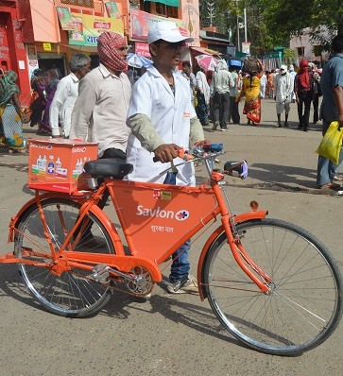
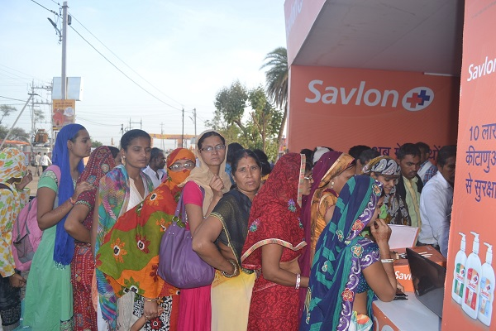
In addition to the hand hygiene programme, Savlon launched an initiative of Savlon Mobile Ambulance on cycles for treating minor injuries. As Kumbh is a massive congregation, to manage crowd, movement of vehicles are restricted. Even for medical first-aid, people have to walk a distance to the nearest medical camp. Noticing this necessity for first aid closer to the ‘snan’ area, Savlon launched the mobile ambulance - The Savlon Suraksha Dal, a team of cyclists with first aid kits. They helped more than 1500 individuals, providing first aid and information about nearby dispensaries and hospitals in case of emergencies.

Result
With these two activities the brand was able to create a brand resonance amongst the millions who attended the mela. The campaign reached and engaged more than 2 lakh people at the congregation, all left talking about the benefits of using Savlon and leading a healthy, hygienic life.

