The Power of Benefit Transfers: Mr. Clean Can Clean Just About Anything
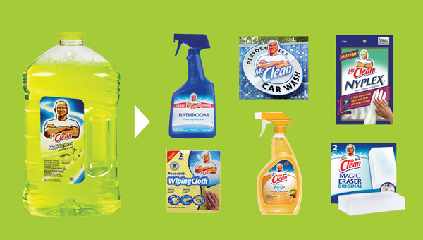
You can name the key benefits of your brand without blinking. But what’s the first thing consumers think about when they hear your brand’s name? If one benefit jumps to mind for most people, your brand might be a good candidate to transfer a benefit to another product category.
This brand extension strategy is one of our 10 Ways to Extend a Brand, and it’s an approach leveraged successfully by popular brands like Mr. Clean. P&G launched Mr. Clean in the 1950’s as a liquid to clean hard surfaces, and the brand quickly built up a reputation for a functional benefit: cleaning power.
Mr. Clean took this reputation as a credible cleaner into other categories. Subsequent decades saw introductions of close-in extensions like toilet cleaner and surface spray. Later, the Magic Eraser surface cleaning pad appeared, followed by a co-branded line with Febreze that included shower cleaner. A wider array of extensions followed, including complementary cleaning products such as rubber gloves and cleaning pads.
In its most dramatic move away from household cleaners, Mr. Clean entered a fragmented category: carwashes. The brand started with a bottled carwash product and later opened carwash locations in Cincinnati, Atlanta and Round Rock, Texas. Most car wash brands are small and local, so Mr. Clean leveraged the power of a national brand in this fragmented category.
Moving from a liquid household cleaner to carwashes may seem like a huge jump, but the brand accomplished it all by transferring a key benefit—cleaning power—to new categories. Eventually, those carwash locations were a natural next step.

The Art of Sequential Extensions: Clorox Cleans Up
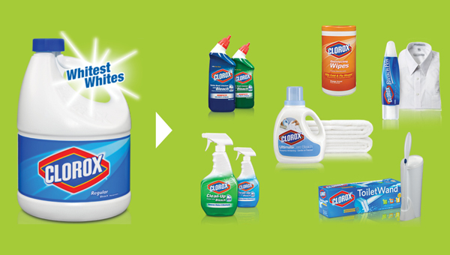
Planning is key to any brand extension, but it’s especially crucial if you want to launch a series of successful new products. Case in point: Clorox.
Today you’ll find the Clorox name on everything from toilet bowl cleaner to disinfectant wipes, but in the early ’90s, the brand had a false start when it introduced a laundry detergent. Why did the new product fail? Consumers were afraid bleach might harm their clothes.
A short time later, the company tapped me to conduct a brand extension study, and my research confirmed that the Clorox name is synonymous with bleach. But my study also uncovered a key consumer insight: People have a love-hate relationship with bleach. They love that bleach cleans and disinfects but worry about it being toxic and damaging surfaces.
Clearly, the brand’s greatest leverage revolved around bleach, so we needed to identify product categories where this key component would appeal to consumers. This approach follows a strategy from our 10 Ways to Extend a Brand: Transfer a Component. It’s when a company takes a component, flavor, color or in this case ingredient that’s closely associated with a brand to create a new product in a different category.
To help Clorox deploy this strategy, I created a plan with both short- and long-term extensions and advocated introducing a household sanitizer or cleaning product first. This move jumped the brand out of the laundry room and into an arena where consumers value bleach’s germ-fighting power on tough surfaces.
By making the leap to the household cleaner aisle, Clorox expanded the perception of the brand and paved the way for later extensions like toilet bowl cleaner. Each new product built on the last thanks to a careful brand extension plan, the key to mastering sequential extensions.

Brand Extension Research: Case History - CARNATION A Consumer-centric Approach
Carnation is a brand that was nationally known and was thought to be a good candidate for expanding into a variety of other food and beverage areas. At the time of our study, Carnation was found on evaporated milk, powdered (dry) milk, Carnation Instant Breakfast, hot cocoa mix, fresh milk, ice cream, yogurt and various other dairy case items. However, the fresh dairy side of the business was only in the western part of the United States. When asked what business the brand was in, management gave various definitions – a dairy company, a milk company, a nutrition company, a progressive multi-product company.
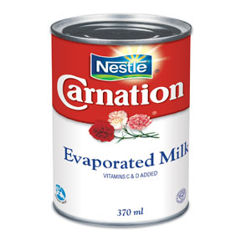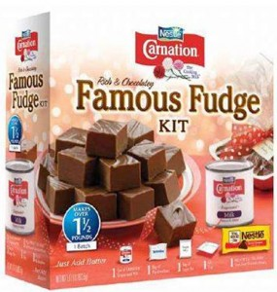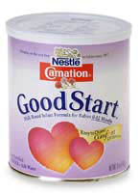
Leverage an Ingredient
This internal conventional wisdom turned out to be different from the view held by the consumer. Carnation was associated with evaporated milk and to a much lesser extent powdered milk – period. As a result, consumers did not think of the company behind the brand as a dairy, a milk company or anything like that. When compared to dairy company brands, Carnation was seen very differently. "Carnation makes base foods, ingredients and mixes, not finished ready-to-eat foods. Carnation was seen as wholesome, but not a nutrition company.
Defining the 'Business' of the Brand
Products that used milk as a primary ingredient were viewed as appropriate for Carnation. There were properties such as creamier, richer, more wholesome, etc. that translated to any Carnation brand extension. Most dairies were regional, so a national brand owning the properties of milk as an ingredient was a viable idea. One interesting concept that appeared to have fit and leverage was infant formula. A number of people thought that there already was a Carnation infant formula in the marketplace. This may have occurred because historically, some mothers used Carnation evaporated milk as an ingredient in making their own infant formula. As a result of this finding, development began on a Carnation infant formula.
Creating a Brand Plan
The parent company of Carnation, Nestlé is the world's largest infant formula producer. Using their formulations and technology, a number of formulas were developed for use in the American market. The existing infant formula market was dominated by two pharmaceutical companies. Their brands – Enfamil and Similac – had names that were more "drug-like" to mothers. In contrast, Carnation was a more "food-like" brand. In keeping with that differentiation, the name Good Start was chosen to launch the new line of formulas. Carnation formula based baby cereal was launched later. Over time, management wanted to re-brand the formulas Nestlé to be in keeping with their worldwide formula name. In the U.S. these formulas have been very successful with sales in the hundreds of millions of dollars.

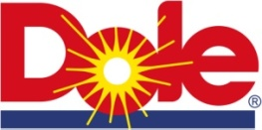Brand Extension Research: Case History - DOLE A Consumer-centric Approach
When Dole management hired us to study their brand, the portfolio of items under the Dole brand consisted largely of canned pineapple slices, pieces, juice, and some other commodities such as bananas, mushrooms, melons, etc. Still, the consumer equated Dole with pineapples. The objective of the company was to move beyond commodity items and pineapple specifically to launch more profitable value-added foods and beverages. The company relayed that pineapple appeals to a segment of the population, but the hope was that the brand could be extended to broader appeal non-pineapple products.
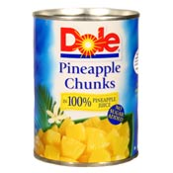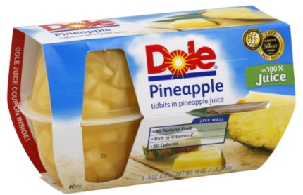
Leverage an Ingredient
The results of the study of Dole revealed (not unexpectedly) a strong connection to pineapple. However, the associations with pineapple were fresh, clean, bright, sunny, and the imagery of a wholesome outdoor lifestyle. It was seen as the best of Hawaii – the fun, the food and sunshine in the most exotic and romantic of settings. Dole represented a “Sunshine Lifestyle,” which translated to sunshine fruits and products that would contain these. Dole was perceived to be all natural, not full of additives or preservatives.
Defining the 'Business' of the Brand
As a result, a variety of brand extensions emerged from this work:
• Dole frozen Fruit ‘N Juice Bars
• Dole Fruit Sorbet
• Dole Fruit ‘N Cream Bars
• Dole 100% refrigerated Pineapple Breakfast Juice (and other blends such as pineapple orange)
• Dole Whole Fruit Coolers
Although all of these product lines originally included a pineapple flavor, the dominant seller was often some other flavor like strawberry or orange. As predicted, the consumer welcomed non-pineapple flavors from Dole. The Fruit 'N Juice Bars, for example, were a characteristic product containing only fruit and juice. This stayed true to the leverage point that Dole was natural, not manufactured or artificial.
Creating a Brand Plan
Using the "sunshine lifestyle" definition of the business, we cooperated with Landor Associates in conducting an international survey about the Dole brand. The sunshine imagery was confirmed and an appropriate new logo was designed by Landor. Brand extension activity has continued at Dole with the launch of various items, some that contain pineapple and some that do not.

